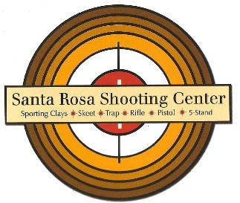 | “First Responders Day”  at  Santa Rosa Shooting Center  March 4, 2021 | 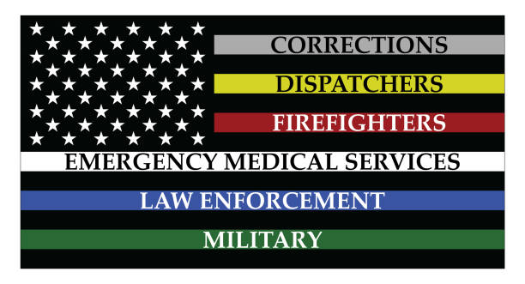

We would like to invite all First Responders that work in Santa Rosa or Escambia County to Santa Rosa Shooting Center on March 4, 2021 to enjoy our facilities at no charge.

This free day at Santa Rosa Shooting Center is our way to thank you for your service, loyalty and hard work protecting us and responding in times of emergencies. Your efforts are appreciated and we want to recognize your commitment to the communities of Santa Rosa and Escambia Counties.

Please come out and enjoy the many different shooting disciplines we offer. These shooting disciplines include a pistol/rifle range, a sporting clays course, a skeet field, a five stand and a trap field.

We do ask you to bring your own firearm and ammunition, along with your eye and ear protection.

You will need to bring your valid first responder identification to take advantage of this special.

Lunch will be provided for you by Chris Myer’s Automotive

In order for us to get a headcount for food, we ask you to call us and make a reservation to attend this event. Please make your reservations by February 28, 2021. When making your reservation please let us know if you plan to come in the morning (9:00AM to Noon) or in the afternoon (1:00PM to 4:00PM). We also need to know which one of our shooting courses you want to use. This information will help us manage the range and minimize wait times. We are closed on Mondays and Tuesdays, so please call Wednesday thru Sunday between 9AM and 4:30PM to make your reservation.

Santa Rosa Shooting Center is located at 6950 Quintette Road, Pace FL 32571. Our phone number is (850) 995-9377.

Lunch will be available from 11:30AM until 1:00PM. Between the morning and afternoon sessions. Afternoon sessions are asked to arrive early to take advantage of lunch.

Thank you for all that you do and the sacrifices you make for all of us. Our communities are great places to live and you are a major reason for that.

